# Styling Changes

In sprint 1, styling was changed from the initial prototype to a new style. The style review came about during transition to use a Responsive website layout. This section will demo the changes.

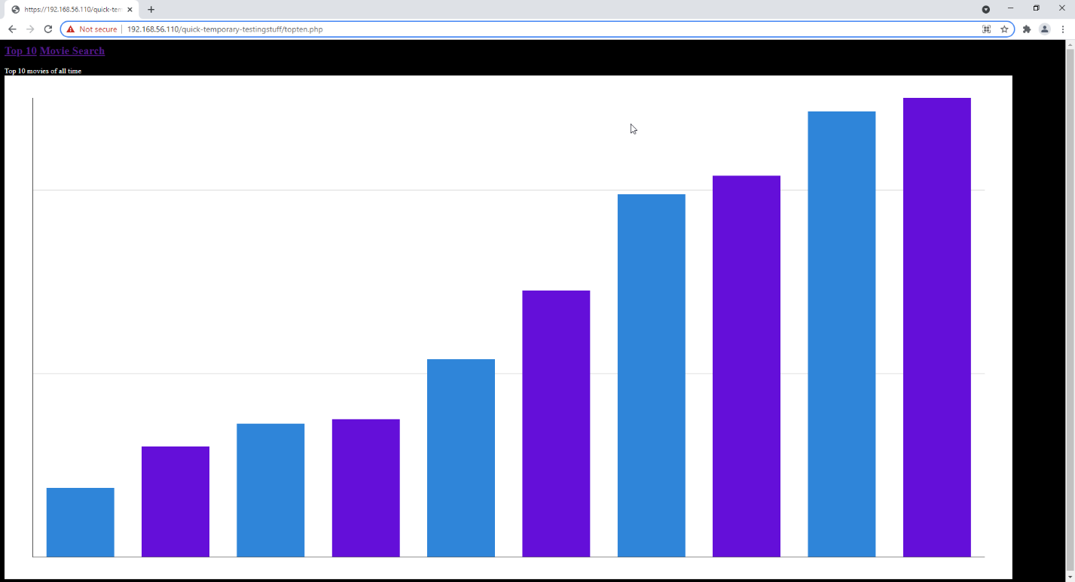

. Original styling for Graph

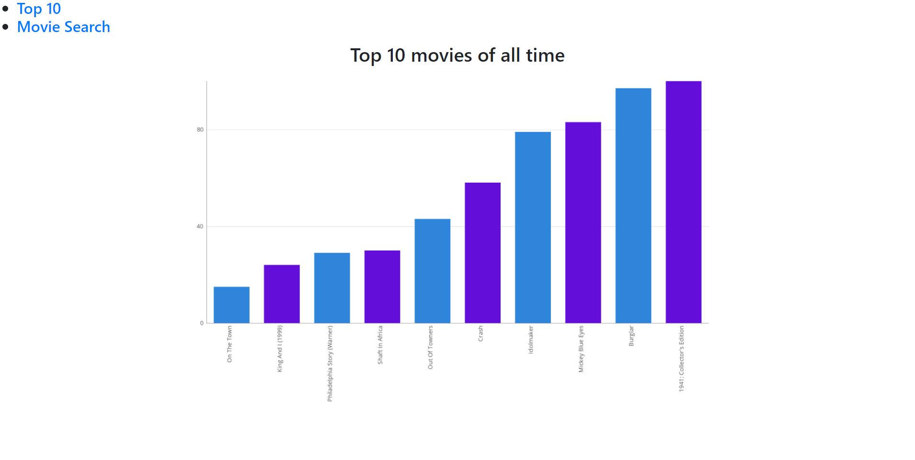

. New Styling for Graph

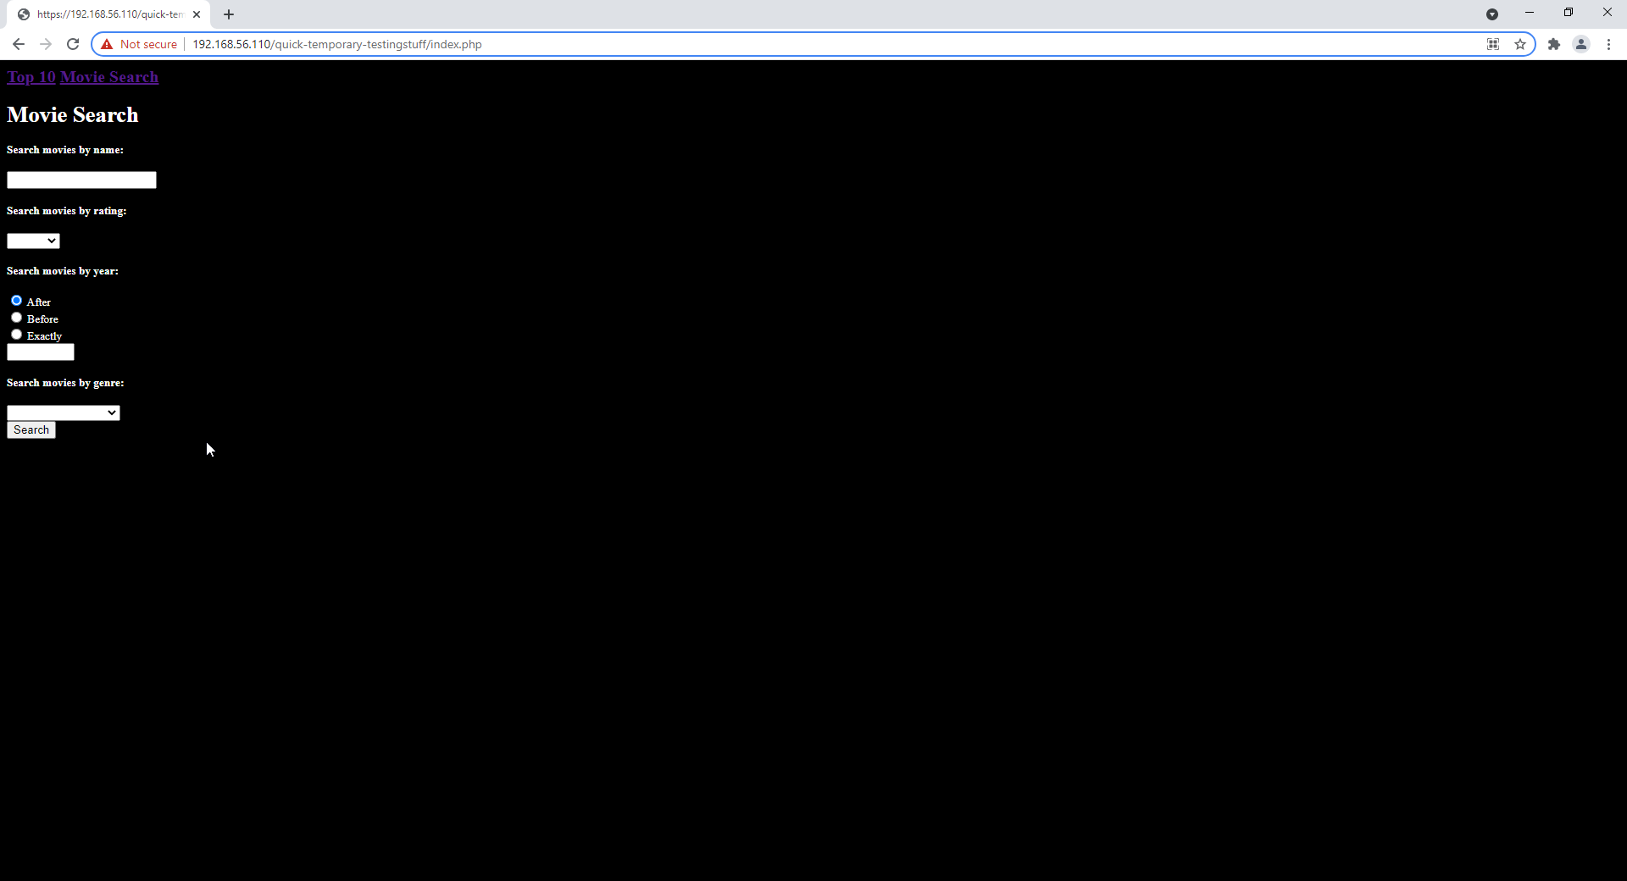

. Original styling for search page

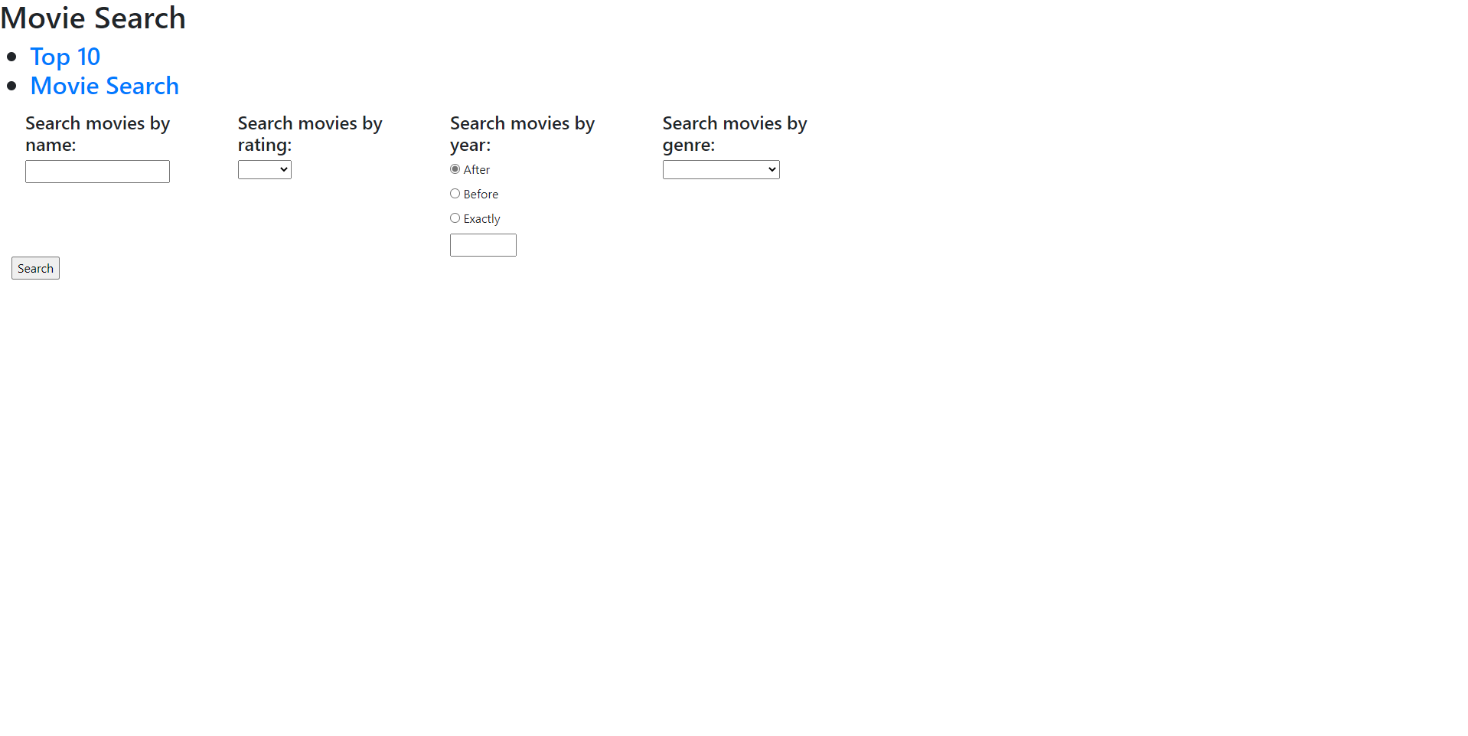

. New styling for search page

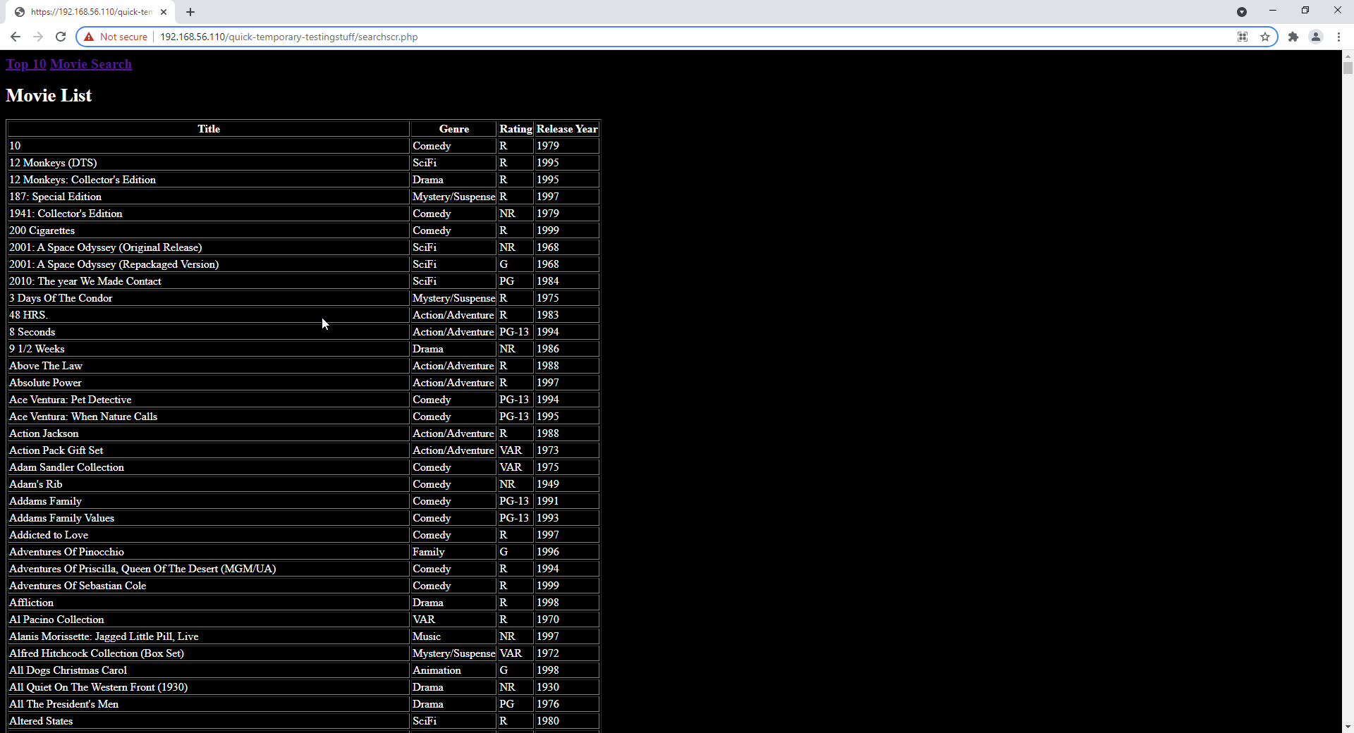

. Original styling for search results page

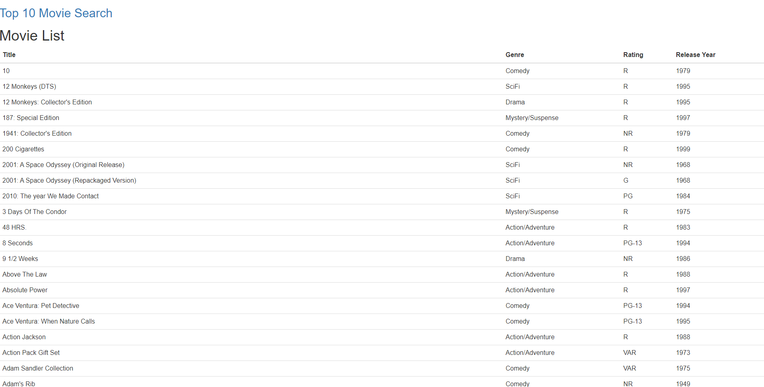

. New styling for search results page

## Styling comments

The new style improves on the layout and visual pleasantness of the pages. The new style is still subject to change and may include more complex colors and fonts to match user requirements.